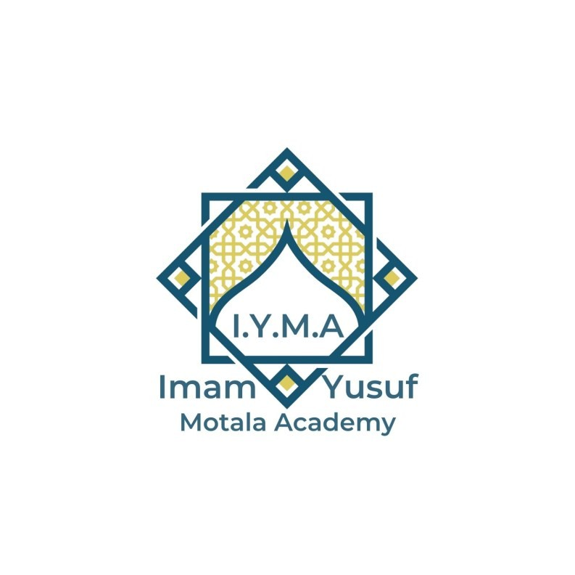
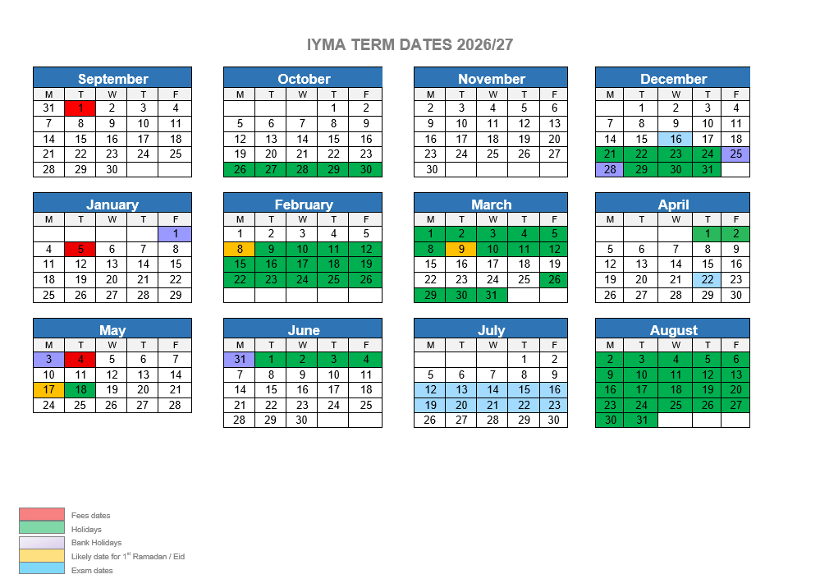

Madrasa Annual Holidays, Exam & Fee Dates

Important Dates 2026 – 2027
1448 AH – 1449 AH

Dates are subject to change with prior notice.
Dates for Termly Contributions 2026-27

Payment | Date | Amount | Amount  Hafiz Class
Dates for Termly Contributions 2026-27
Term 1
Fees week:  Tuesday 1st September to  Friday 18th  December 2026 | September -  December 2026  (15 weeks) | (£10 a week)  £150 | (£15 a week)  £225
Term 2  Fees Week:  Monday 5th  January 2026 to Friday 30th April  2026 | January, February and April 2027  (12 weeks including Ramadhan week-  ends) | £120 | £180
Term 3 | May - July 2027
Fees Week:  Monday 4th May to Friday 28th July 2027 | (12 weeks)  Classes will continue for Hafiz class until Thursday 13th August | £120 | £210
ONLINE PAYMENTS: |  | CASH PAYMENTS
Account Name: Imam Yusuf Motala Academy Account No :71398073  Sort Code :050303  Reference : Your child’s name |  | Fees must be paid during these weeks. It is advisable you give your money to your child in a seal envelope with your child’s name and teachers name.

Important Dates
Students to return to Madrasa – Beginning of Academic Year | Tuesday 1st September 2026
Exams  Islamiyah series Fiqh Exam (Annual) For book 3+ | Wednesday 16th December 2026
Ramadhaan starts:  Ramadhan Madrasa Timing and Dates | Saturdays: 13, 20 &  27th Feb  Sundays: 14, 21, & 28th Feb
Exam  Islamiyah series Aqaaid Exam  (Annual) for book 3+ | Thursday 22nd April 2027
Annual Exams & Activities:  - Quran / Qaida / Tajweed Exam  - Supplications Exam  - Islamiyah series Tareekh &  - Seerah Exam book 3+  End of year activities:  - Results / prizes  - Parents’ evening  - Parties  - Last academic day: | Period commencing - Monday 12th July 2027 till Friday 23rd July 2027  Please avoid any absences  during this period.

